49th ANNUAL NEW BERLIN 4th of JULY FAMILY FESTIVAL

2017 Theme “Freedom Is…”

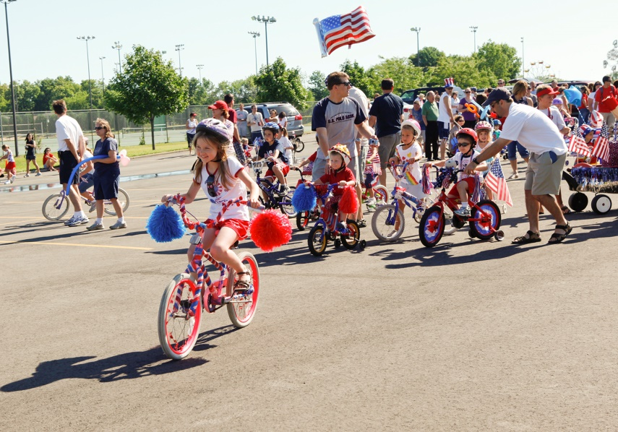

*Be part of the*

**Mini-Parade**

**Tuesday, July 4th, 2017**

**Line-up at 9:00 AM**

***Location:*** *City Hall Main Parking Lot*

*New Berlin City Hall, 3805 S. Casper Dr., New Berlin, WI*

**Parade Starts at 9:30 AM**

***Please decorate Kids Bikes, Wagons, etc.***

***Prior to the parade***

*Sponsored by:*

